# @Transactional

The @Transactional annotation in Spring is used to manage **database transactions** declaratively. It ensures that a method (or a group of methods) executes within a **transactional context**, meaning:

* If the method completes successfully, the transaction is **committed**.
* If a runtime exception occurs, the transaction is **rolled back** automatically.

**⚠️ Important Notes**

* Works only on **public methods** (due to proxy-based AOP).
* Won’t work if you call a @Transactional method from **within the same class** unless you use AspectJ.
* Only effective on **Spring-managed beans**.

**🔹 Why @Transactional only works on public methods (when using Spring's proxy-based AOP)?**

Spring AOP (by default) uses **JDK dynamic proxies** or **CGLIB proxies** to apply cross-cutting concerns like transactions.

* JDK dynamic proxies can **only intercept interface methods**.
* CGLIB proxies (used when no interface exists) create a **subclass** and override methods.

Now, here's the catch:

**Proxies can only intercept method calls made from external callers**, and **only public methods** are part of the proxy interface/subclass.

So:

@Transactional

private void doSomething() { ... } // ❌ Won't be intercepted

Even if it's marked as @Transactional, Spring **won’t proxy it** unless it's public — because private, protected, or package-private methods can't be overridden or proxied in a way Spring AOP expects.

**🔹 Why calling a @Transactional method from within the same class won’t work?**

This is called **self-invocation**, and it bypasses the proxy.

Example:

@Service

public class UserService {

public void outerMethod() {

innerTransactionalMethod(); // ❌ No transaction applied

}

@Transactional

public void innerTransactionalMethod() {

// Transaction won't start!

}

}

**Why?**  
Because the proxy is only used when **another Spring bean** calls the method.  
In the example, you're calling the method **directly**, so the proxy (and therefore the transaction) is **not triggered**.

**🔹 Why is @Transactional only effective on Spring-managed beans?**

Because Spring applies @Transactional using **proxies**, and **only beans managed by the Spring container** can be proxied this way.

So:

UserService service = new UserService(); // ❌ Not managed by Spring

service.doSomething(); // @Transactional won't work

Correct way:

@Autowired

private UserService service; // ✅ Spring-managed

service.doSomething(); // Transactional will work

If you manually new the class (not through Spring), you’re not using the proxy at all — so no AOP, no transactions.

**🛠 Workaround for Self-invocation?**

Use **AspectJ** or programmatic transaction management.  
With AspectJ, Spring uses **compile-time or load-time weaving**, so even internal method calls can be intercepted.

# Part 1- Udemy Url - [Notebook](https://notebook.zohopublic.in/public/notes/dcr5za43213ff940049e4857a26389eb54486)

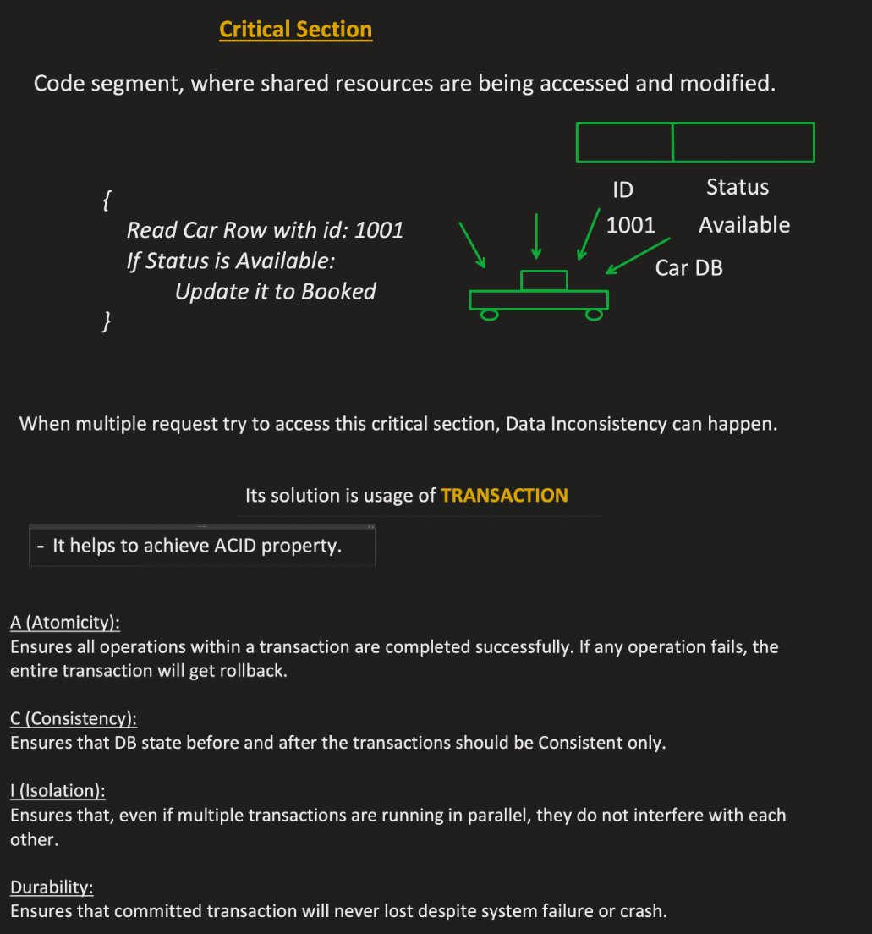

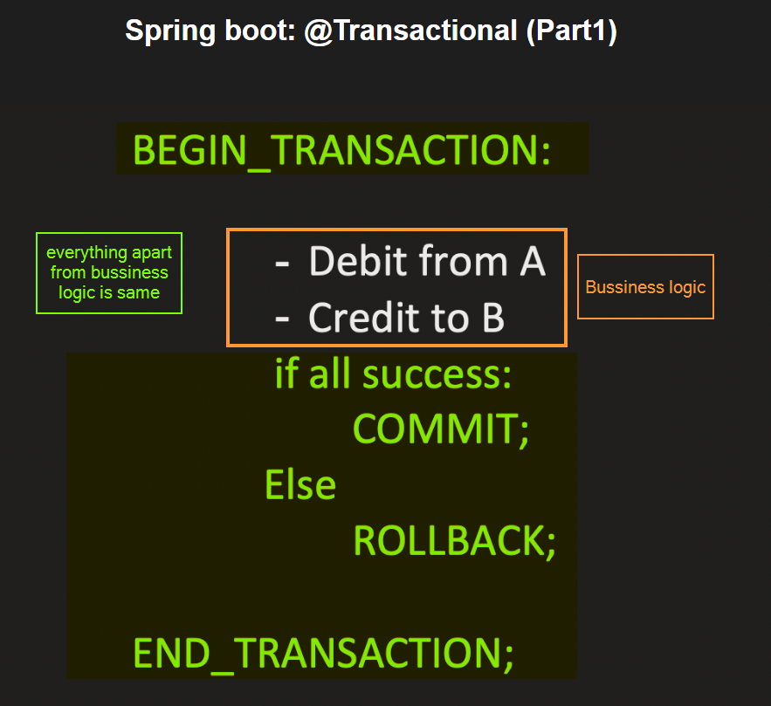

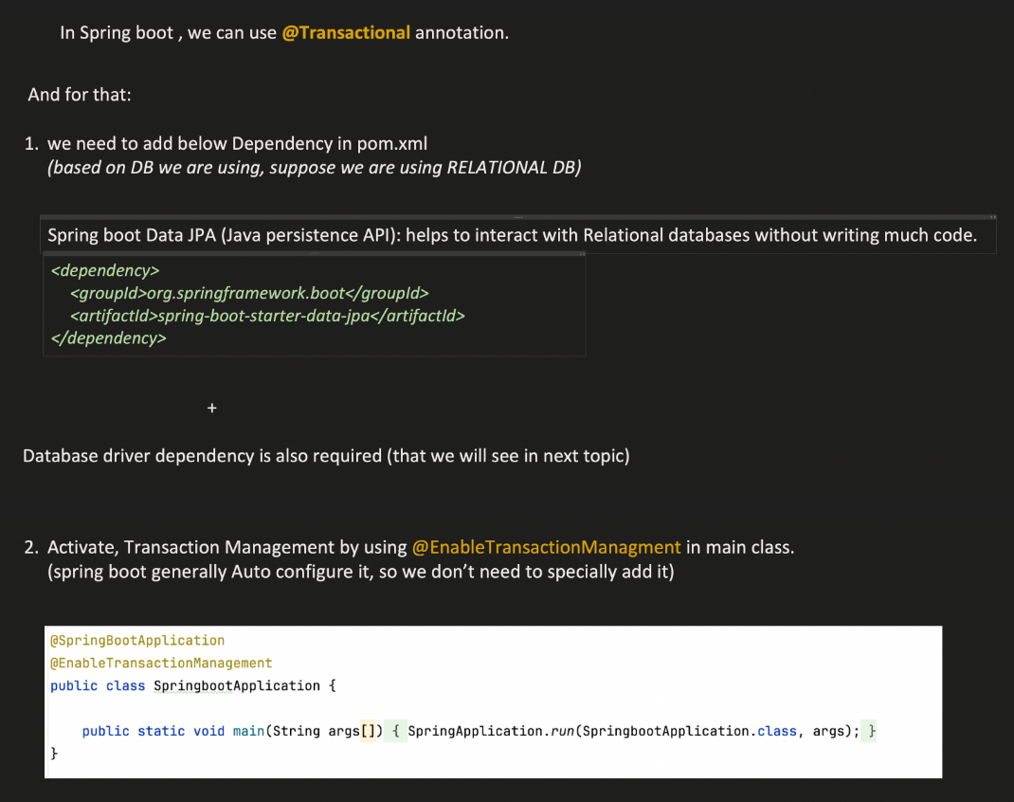

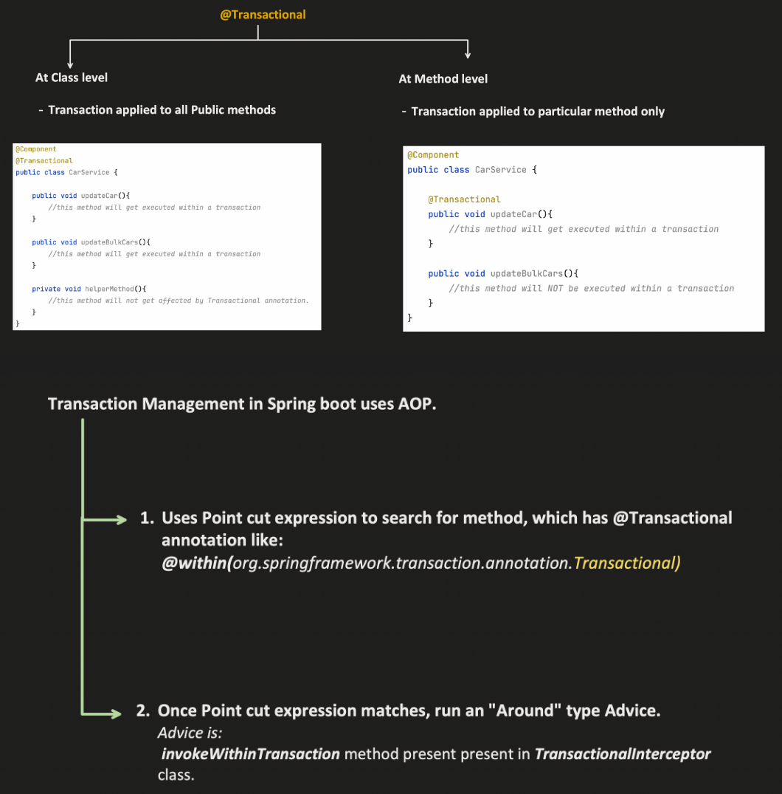

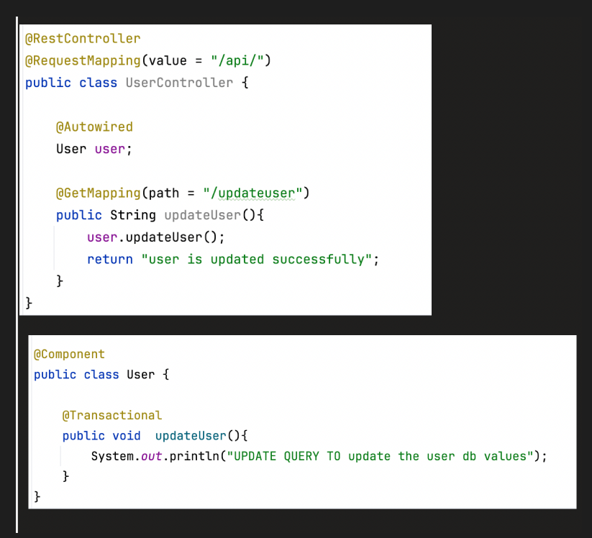

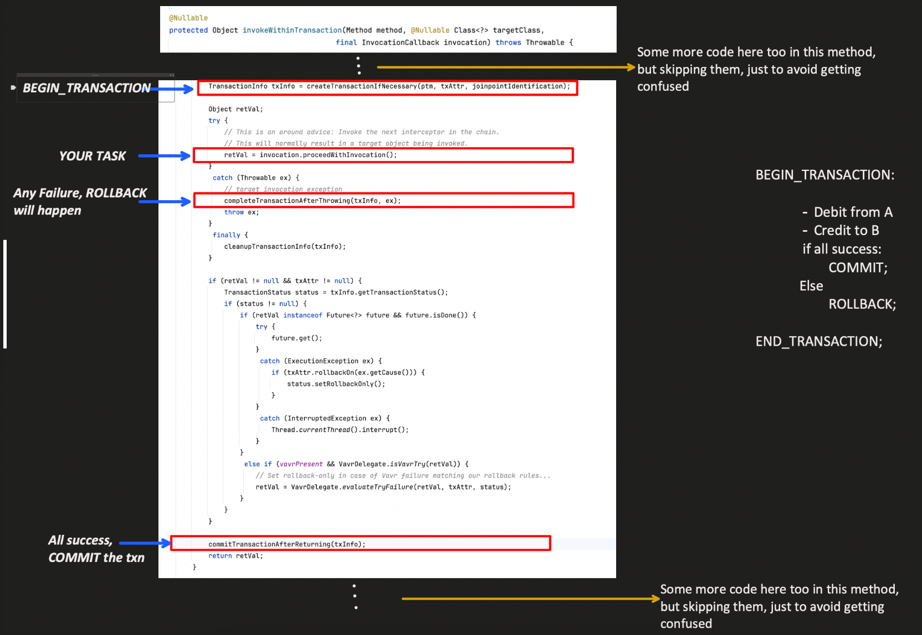

# Part – 2 Udemy Url - [Notebook](https://notebook.zohopublic.in/public/notes/dcr5z827d4c4d67cf491494f30a7733eeb3e1)

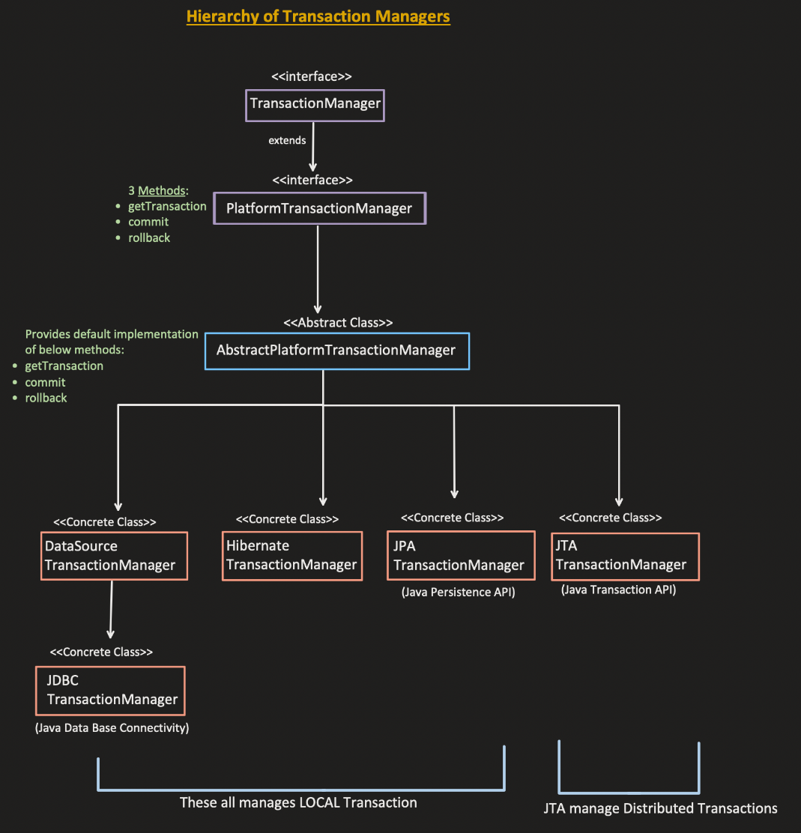

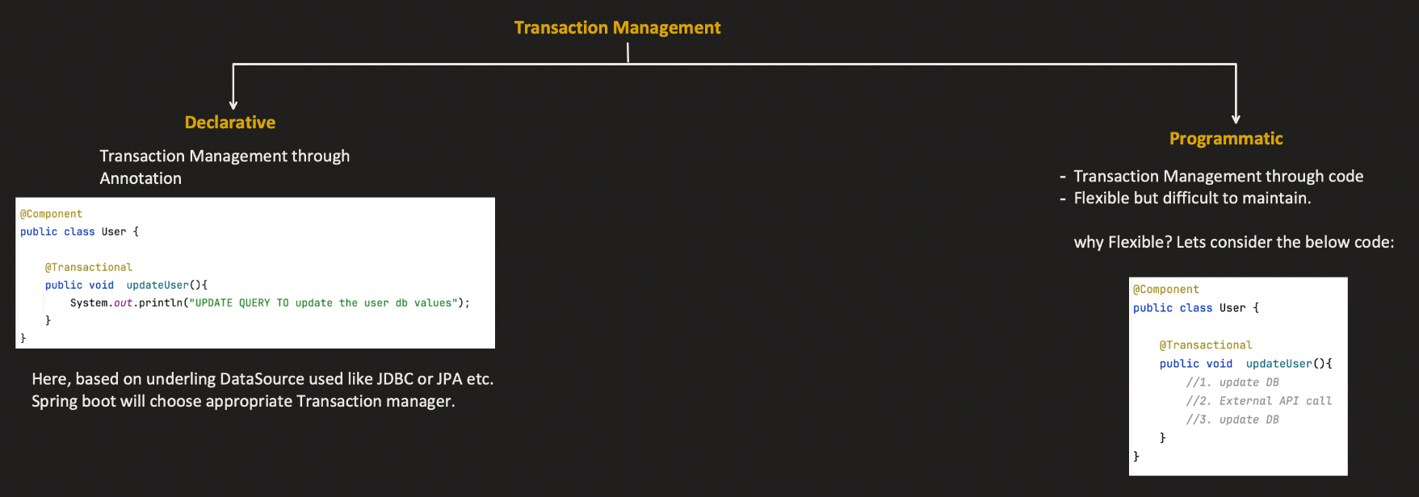

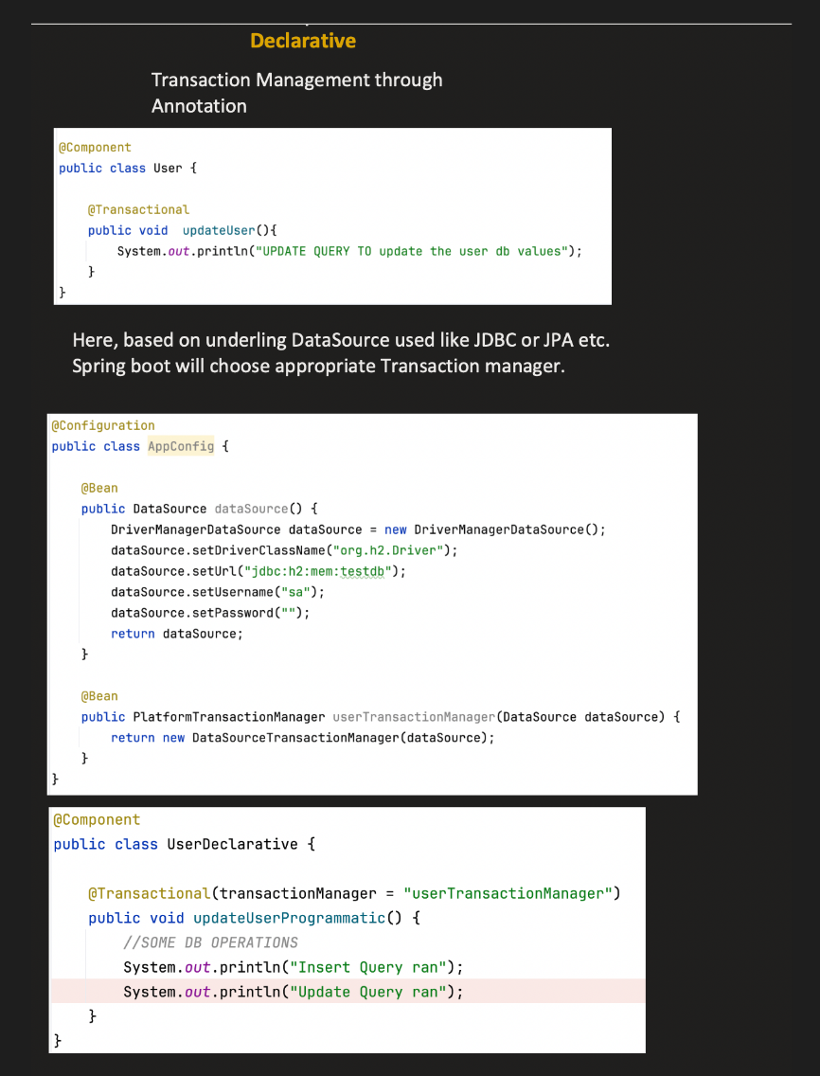

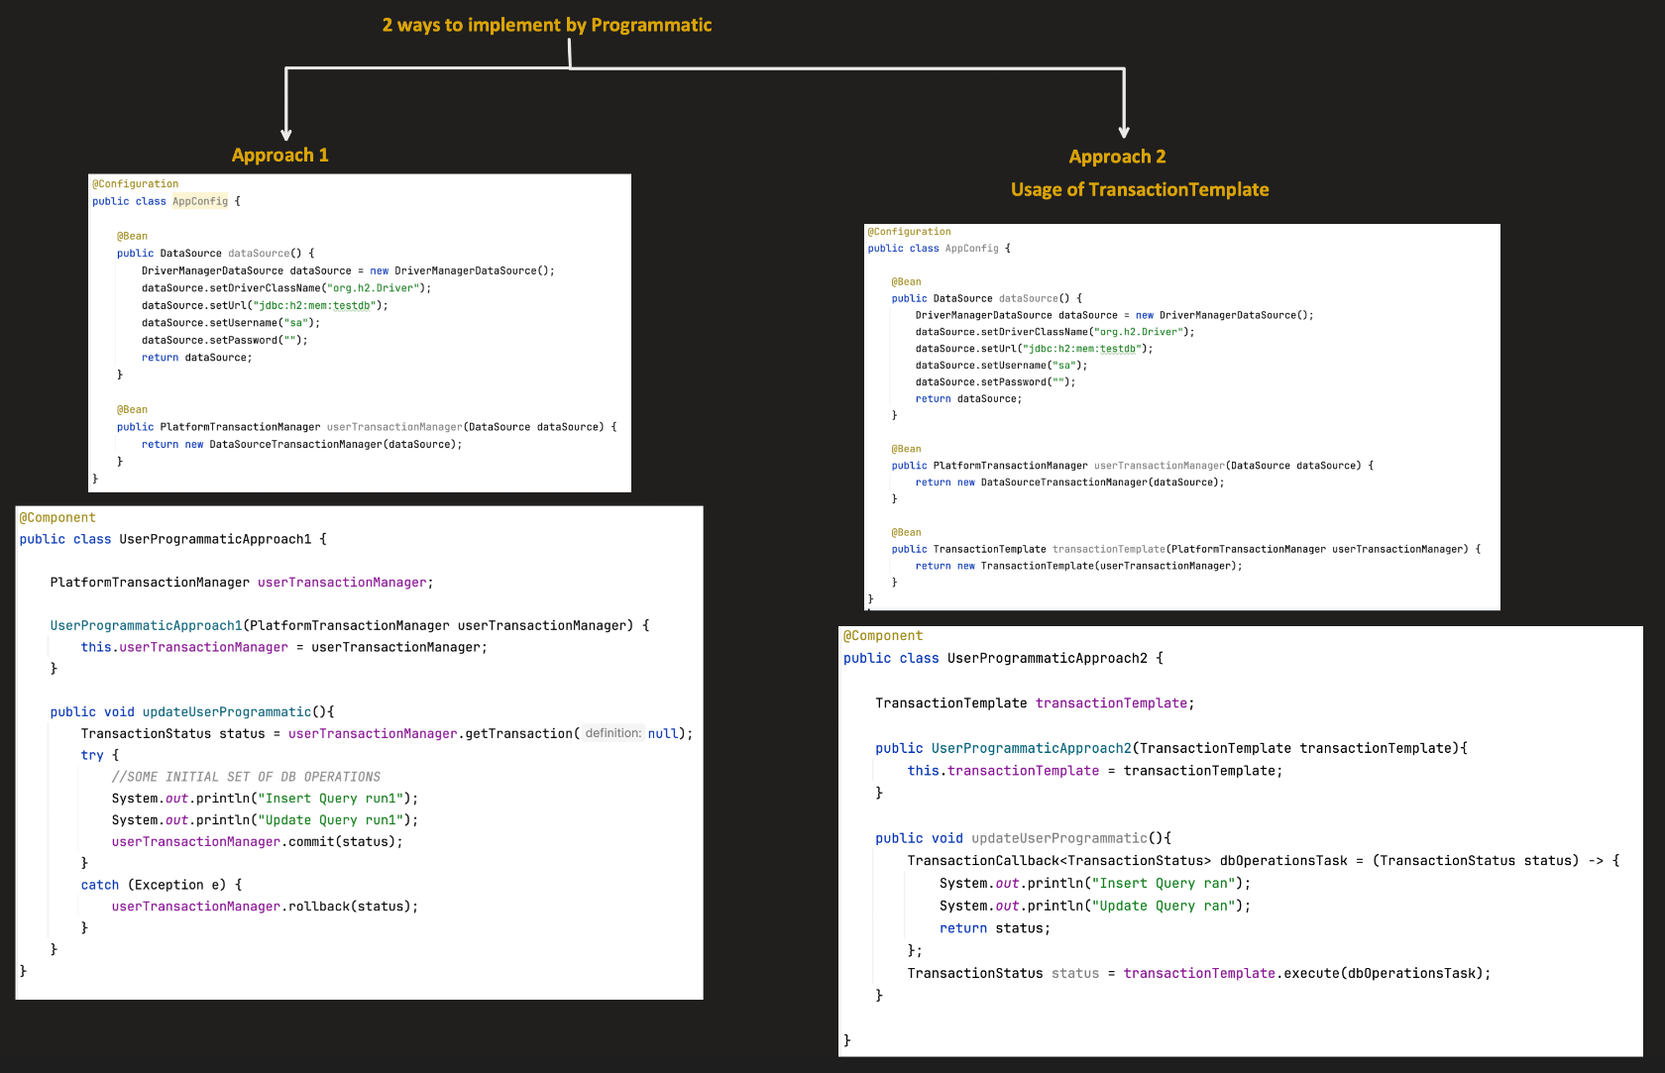

## Propagation

**Propagation** determines how Spring manages transactions **when a method annotated with @Transactional is called inside another transactional method.**

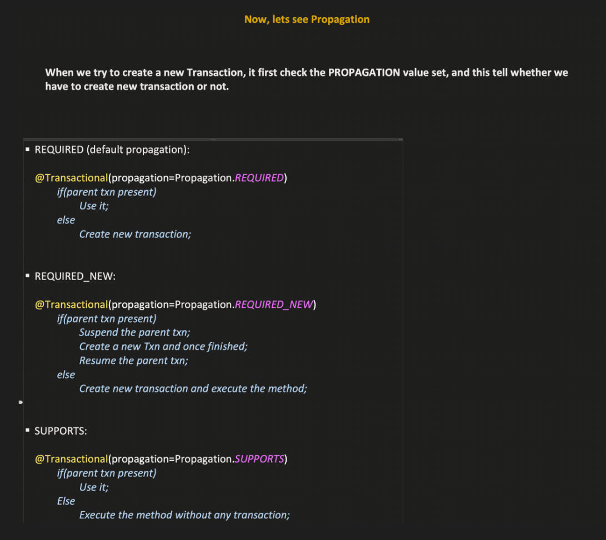

### ✅ 1. REQUIRED (default)

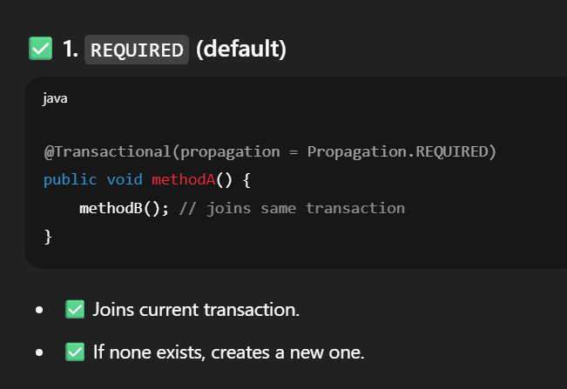

### ✅ 2. REQUIRES_NEW

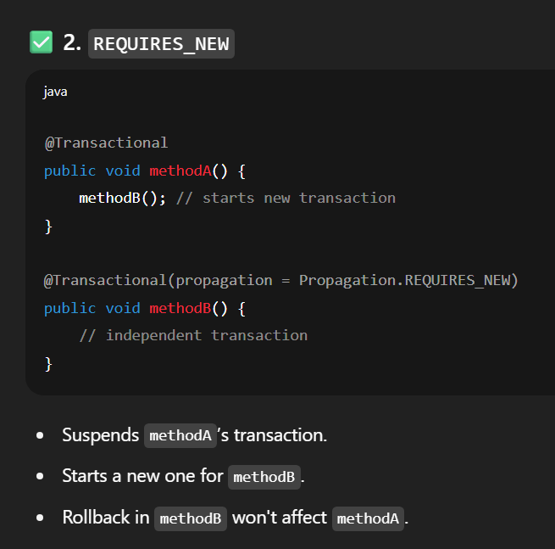

##### ✅ Scenario: methodA calls methodB, and methodB uses REQUIRES_NEW

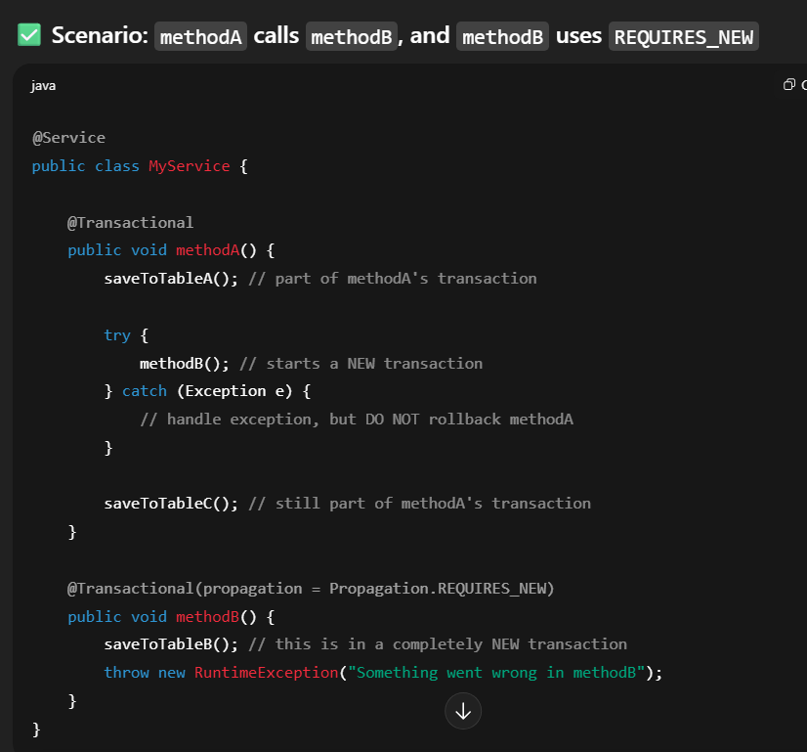

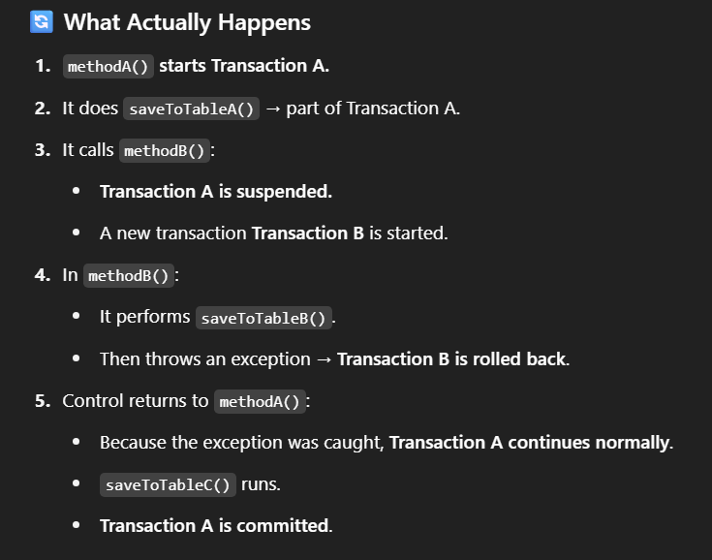

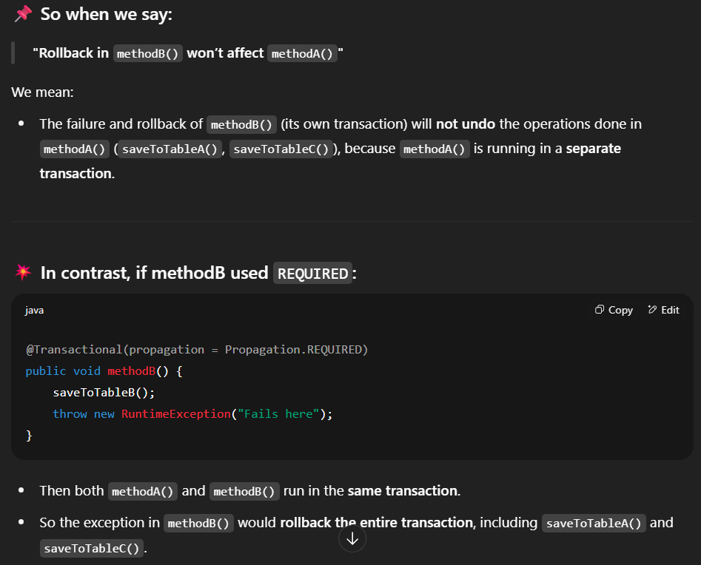

### ✅ 3. NESTED

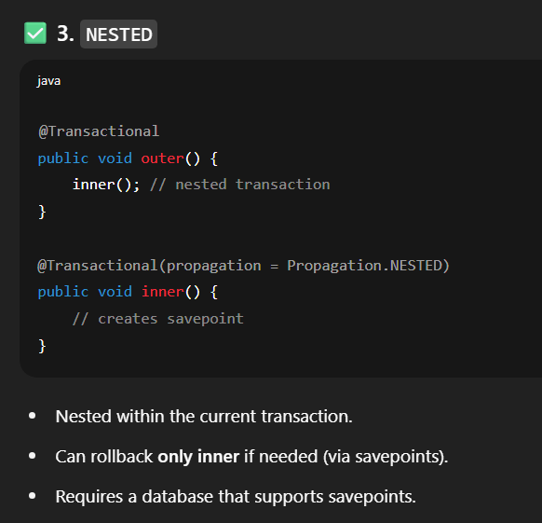

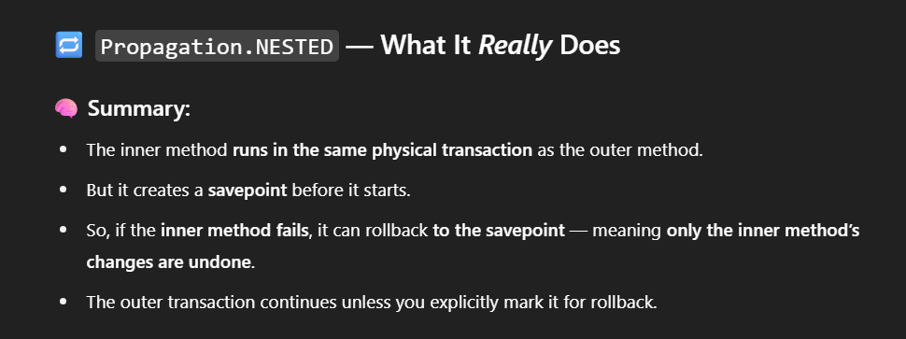

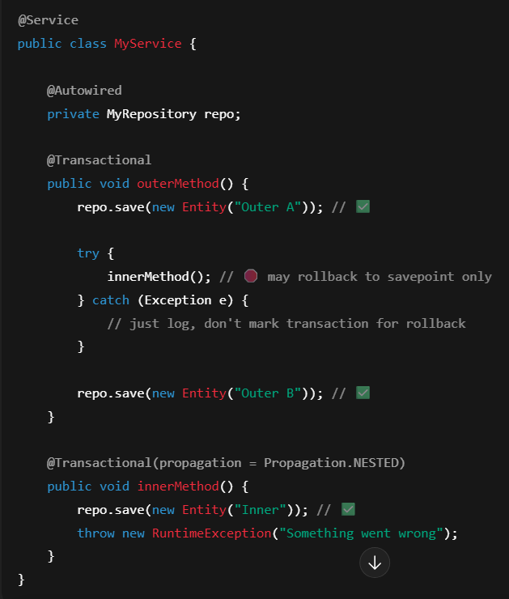

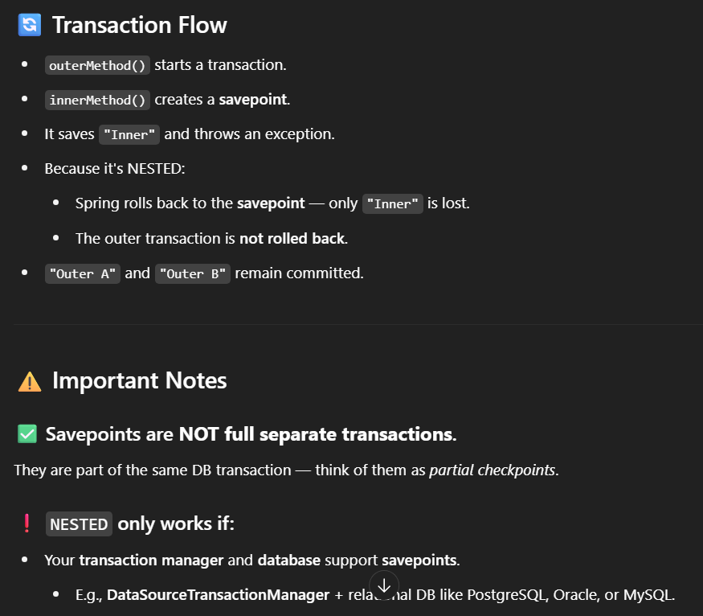

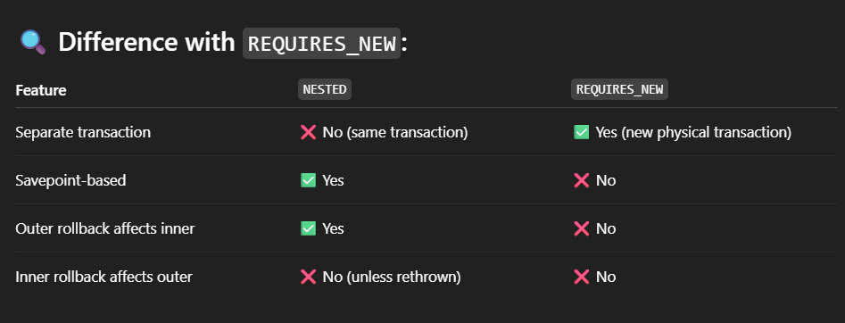



### ✅ 4. SUPPORTS

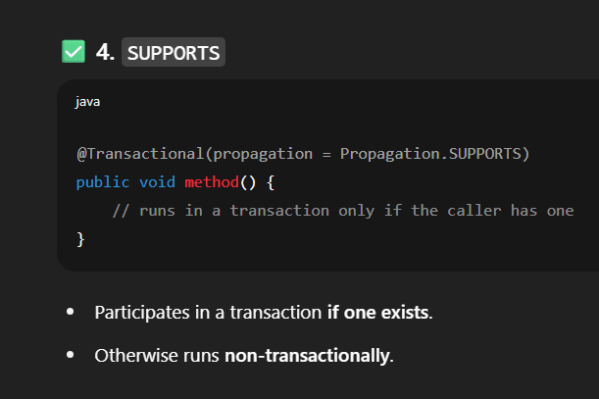

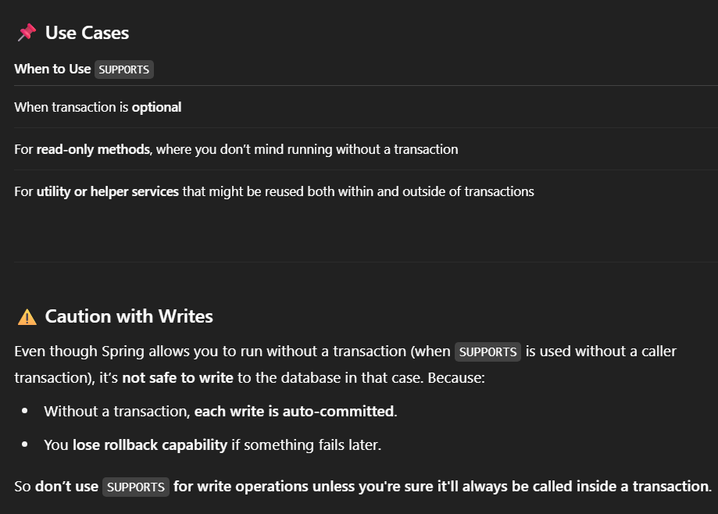

### ✅ 5. NOT_SUPPORTED

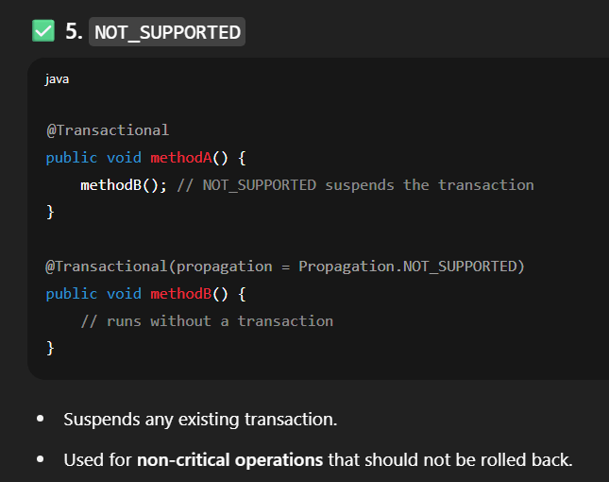

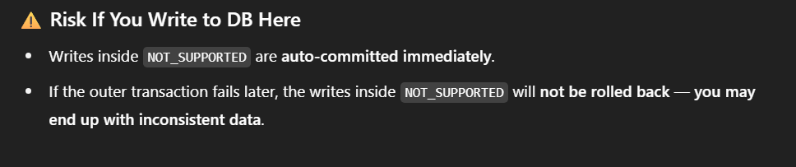

### ✅ 6. NEVER

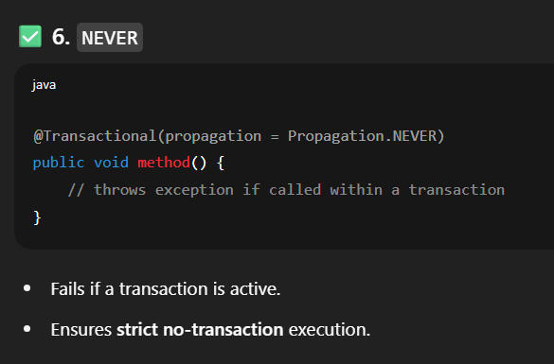

### ✅ 7. MANDATORY

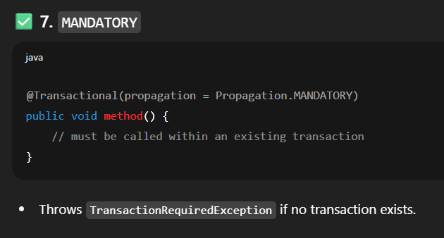

### other

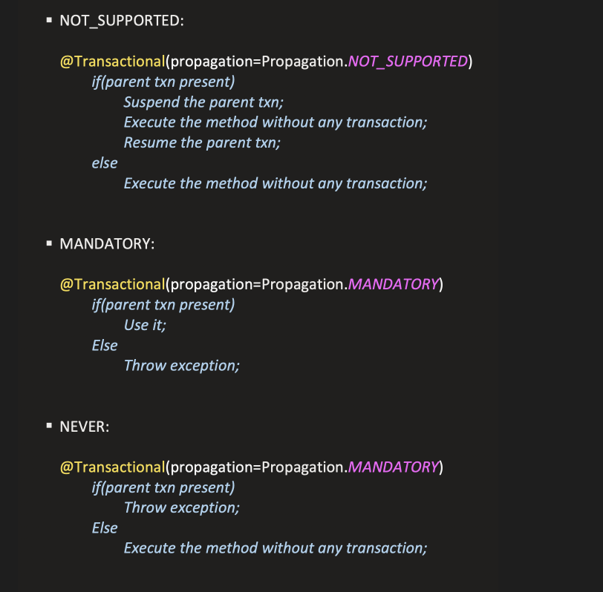

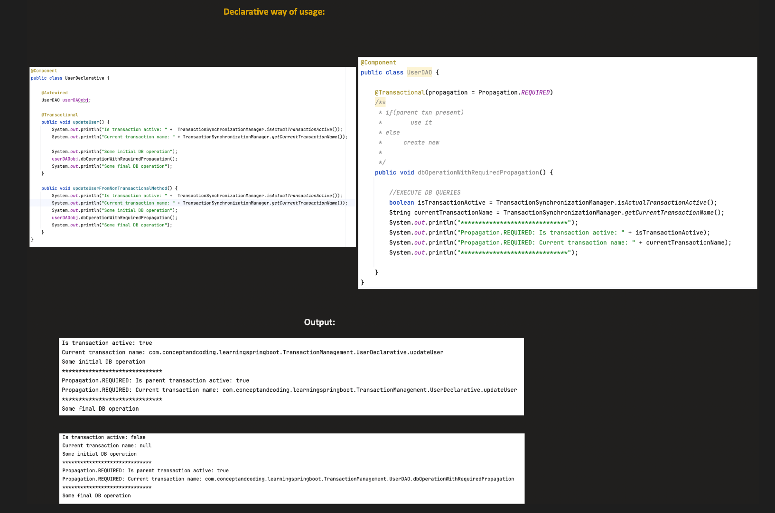

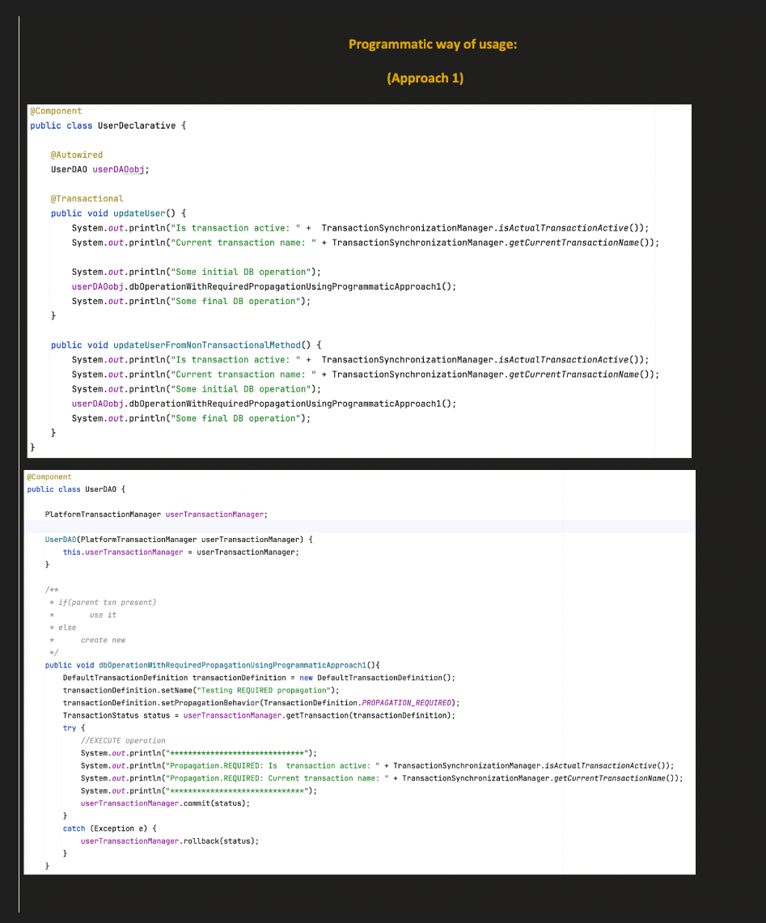

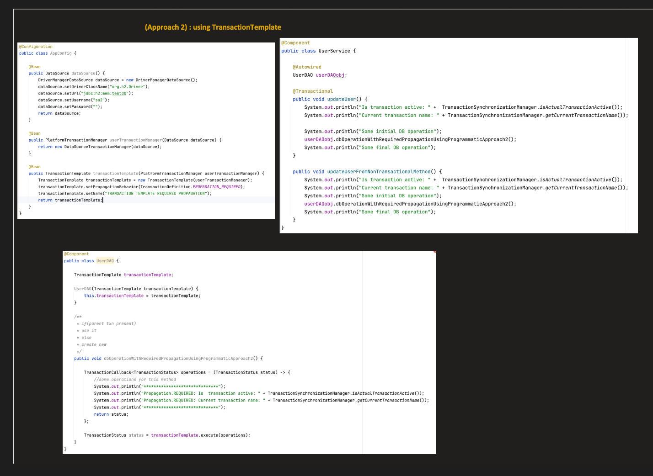

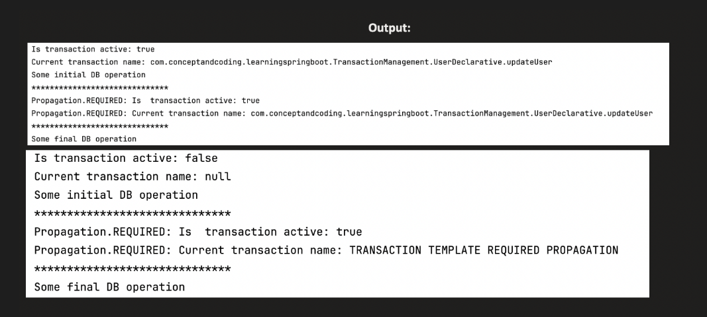

# Part – 3 Udemy Url - [Notebook](https://notebook.zohopublic.in/public/notes/dcr5z613a71d83b66404e8692cfca4790232e)

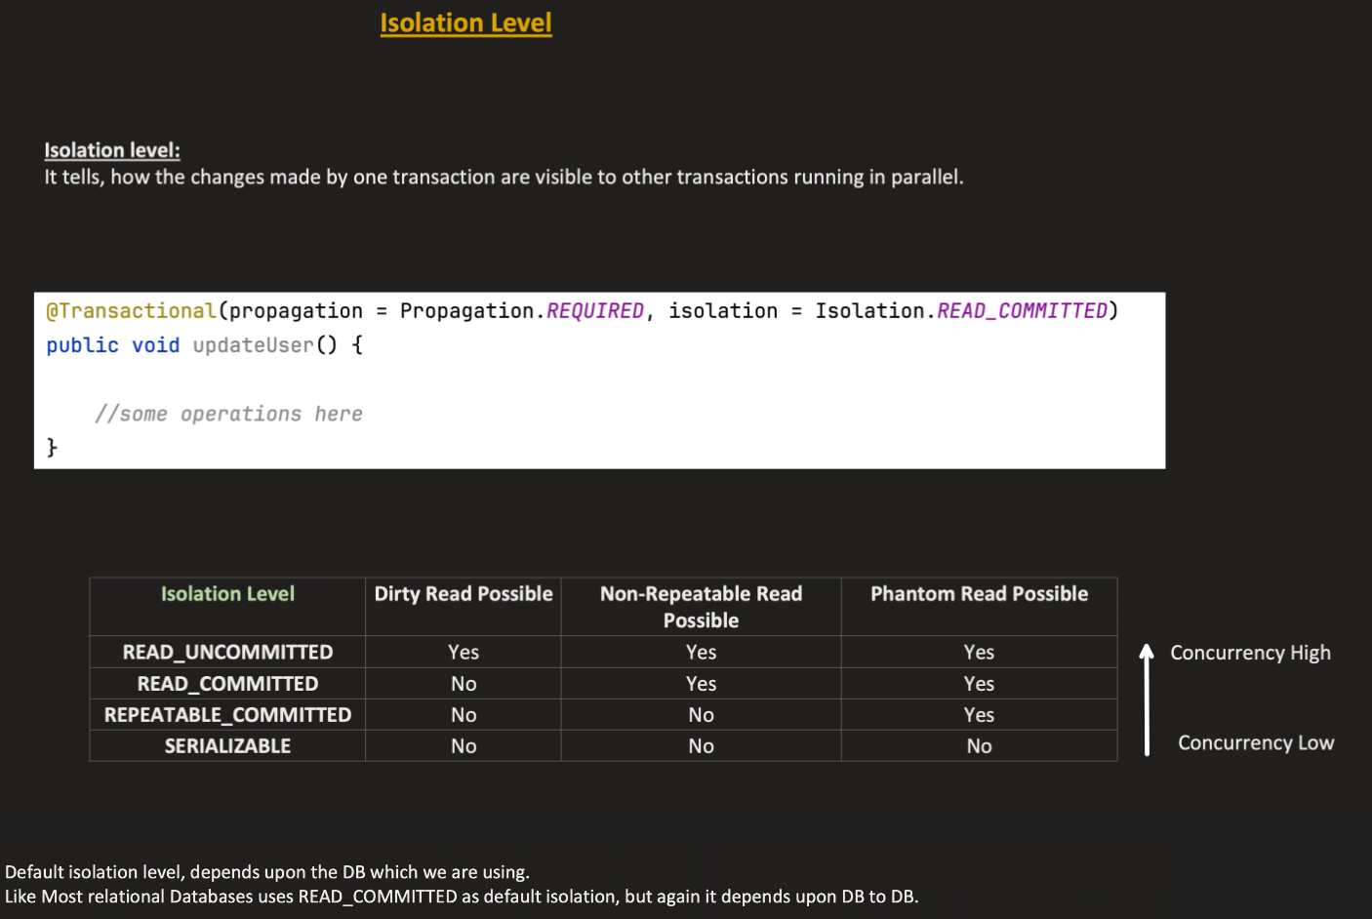

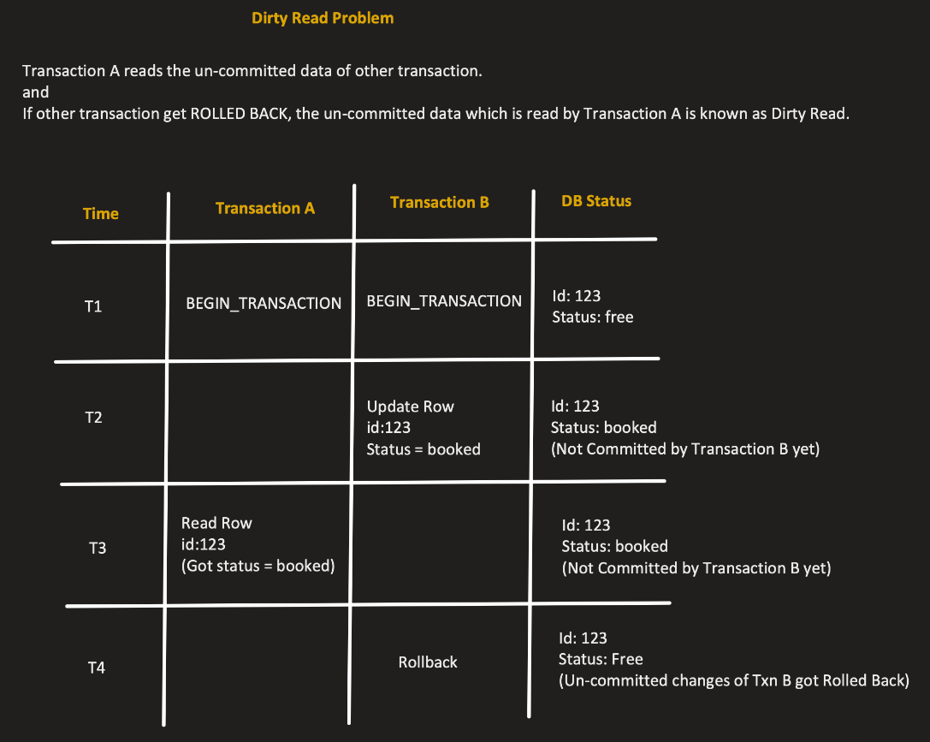

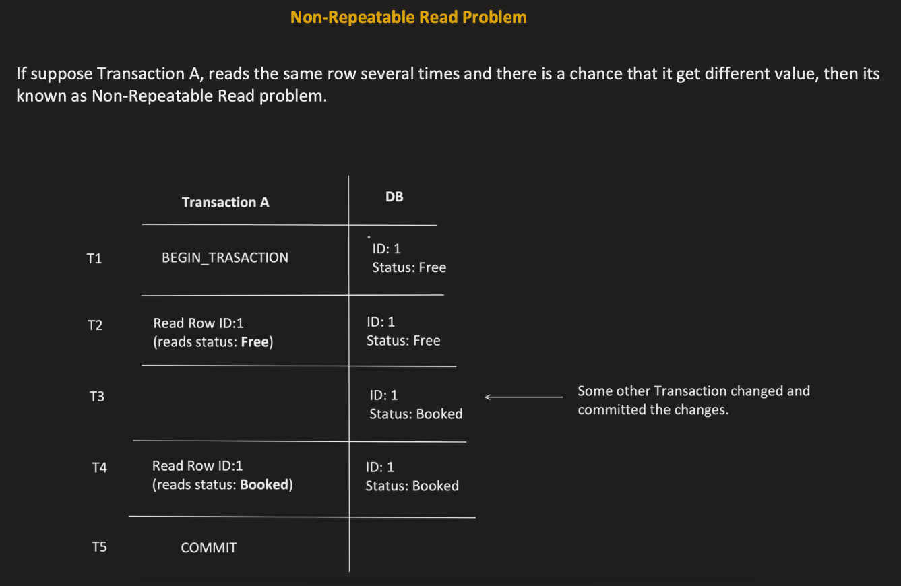

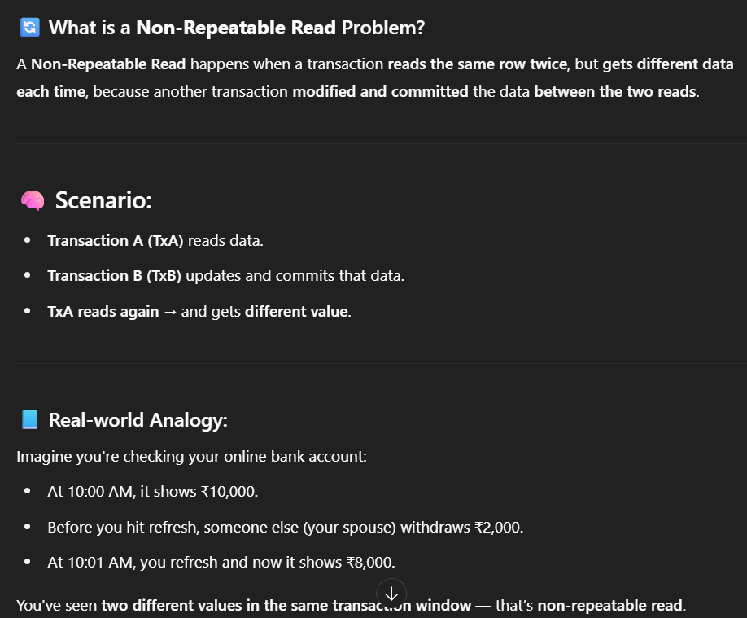

REPEATABLE_READ, SERIALIZABLE prevent this problem.

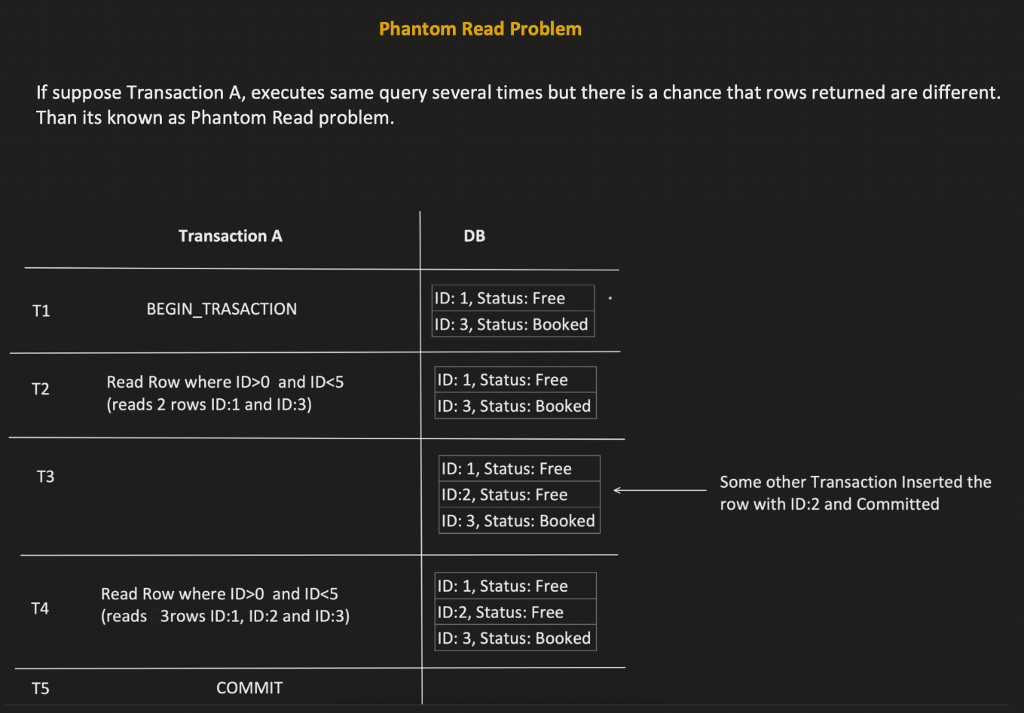

A **phantom read** occurs when a transaction **executes the same query multiple times** and **gets different sets of rows**, because **another transaction inserted or deleted rows** that match the query condition in between.

It’s like the "phantom" rows **appear or disappear** during the transaction.

